Project 3. ECG Signal Processing

Description Electrocardiography (ECG or EKG) is the process of recording the electrical activity of the heart over a period of time using electrodes placed over the skin. These electrodes detect the tiny electrical changes on the skin that arise from the heart muscle's electrophysiologic pattern of depolarizing and repolarizing during each heartbeat. It is very commonly performed to detect any cardiac problems. More details can be found at Wiki page (<https://en.wikipedia.org/wiki/Electrocardiography>)

In this project, we will look at two classes of ECG signals in real captures: one has normal sinus rhythm and the other has cardiac dysfunctions. The signal was recorded at a sampling rate of 360 Hz and a gain of 200 adu/mW. Note that, ECG signal recording is subject to AC coupling distortion caused by 50/60Hz power line. Raw data are saved in two .mat files

project3_data_1.mat

project3_data_2.mat

Assignments (45 Points) 1. (5 Points) Show time domain waveform and power spectrum of dataset 1. 2. (5 Points) Identify power line frequency.

3. (5 Points) Design a digital filter to mitigate the power line distortion. Show the type of design filter, order, together with the magnitude and phase response of filter.

4. (5 Points) Show the power spectrum of signal after power line distortion removal.

5. (5 Points) Large DC can be observed in raw data, which is caused by movement during the recording. Design a digital filter to mitigate movement distortion. Show the type of design filter, order, together with the magnitude and phase response of filter.

6. (5 Points) Show the power spectrum of signal after DC distortion removal.

7. (5 Points) Estimate heart rate. (Hint: detect R peak, and calculate its frequency).

8. (5 Points) Redo steps 1-7 for dataset 2.

9. (5 Points) Analyze the heart rate estimation, and decide which dataset is from cardiac dysfunctions patient.

Project report in IEEE Transaction style is due before deadline

1. Show time domain waveform and power spectrum of dataset 1.
2. Identify power line frequency.

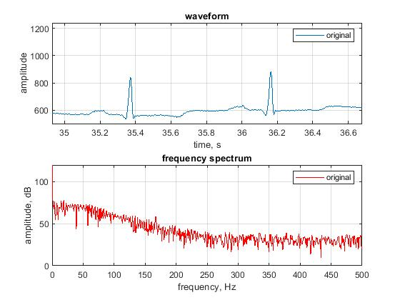

1. Design a digital filter to mitigate the power line distortion. Show the type of design filter, order, together with the magnitude and phase response of filter.

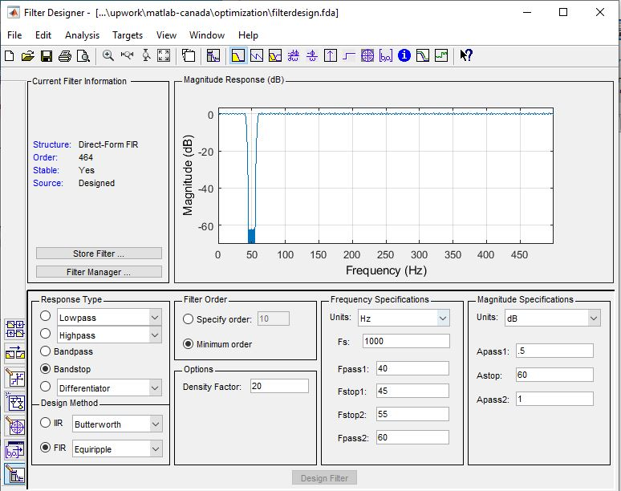

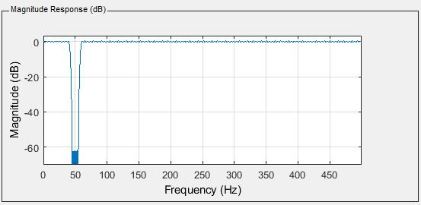

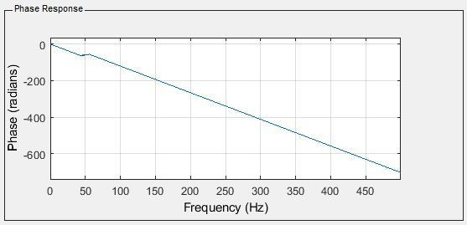

1. Show the power spectrum of signal after power line distortion removal.

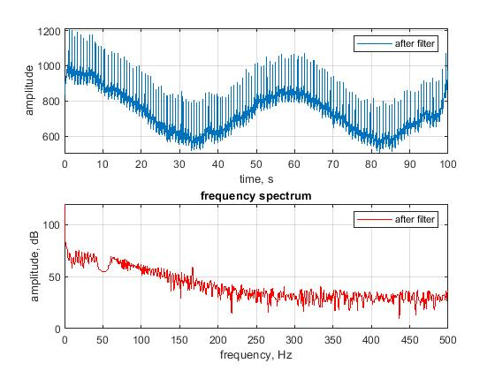

1. Large DC can be observed in raw data, which is caused by movement during the recording. Design a digital filter to mitigate movement distortion. Show the type of design filter, order, together with the magnitude and phase response of filter.

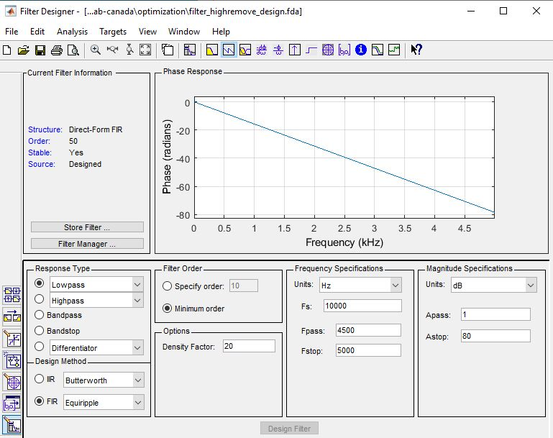

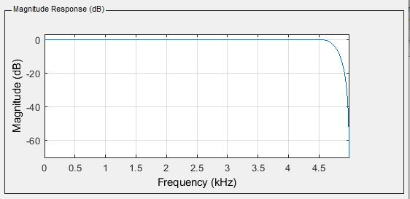

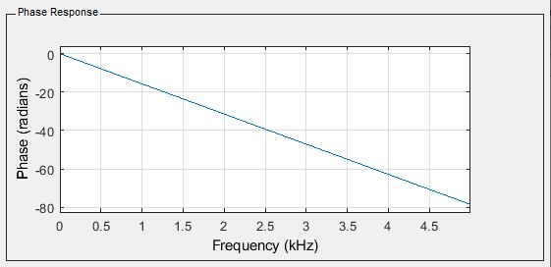

1. Show the power spectrum of signal after DC distortion removal.

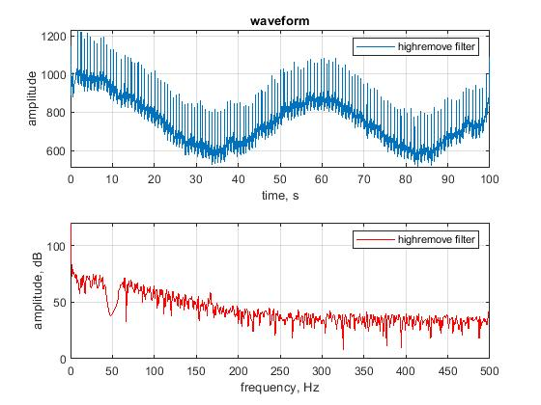

1. Estimate heart rate. (Hint: detect R peak, and calculate its frequency).

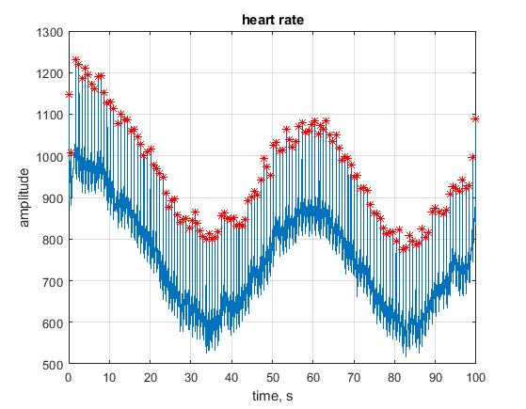

Heart rate is 1.2941 Hz (77 ~ 78 /min)

1. Redo steps 1-7 for dataset 2.

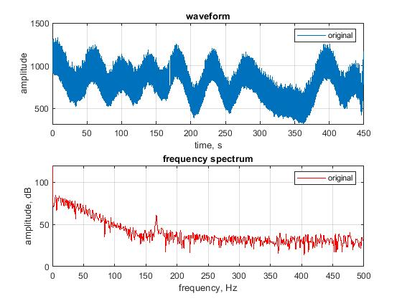

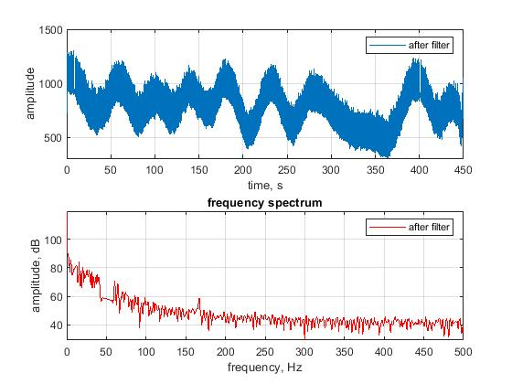

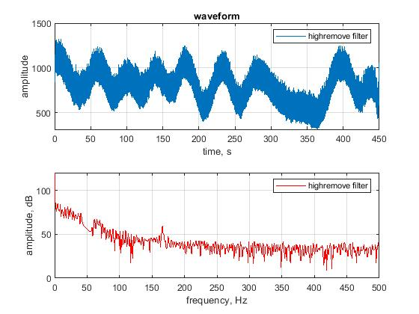

1. Analyze the heart rate estimation, and decide which dataset is from cardiac dysfunctions patient.

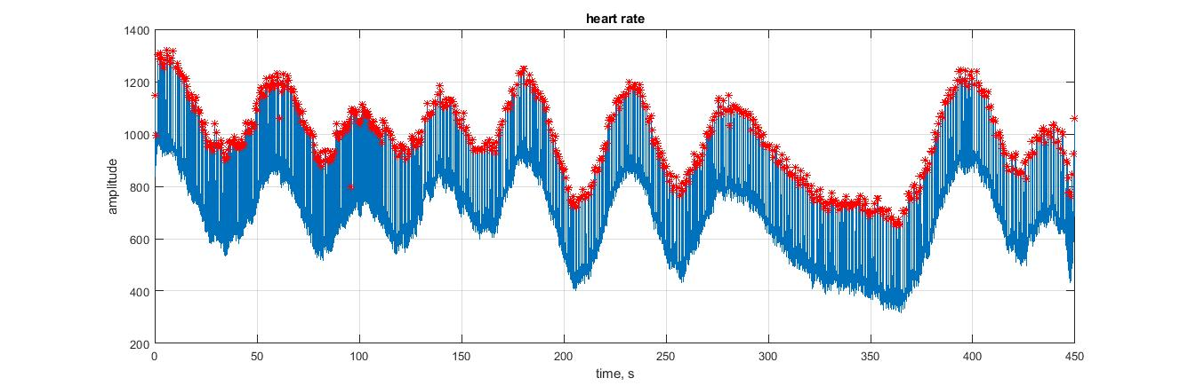

Heart rate is 1.6186 Hz. (97 ~ 98 /min)